Color guessing game:

1. Right click on the “colorgame.html”, click on “open with” option. Open the file in any one of the browser.

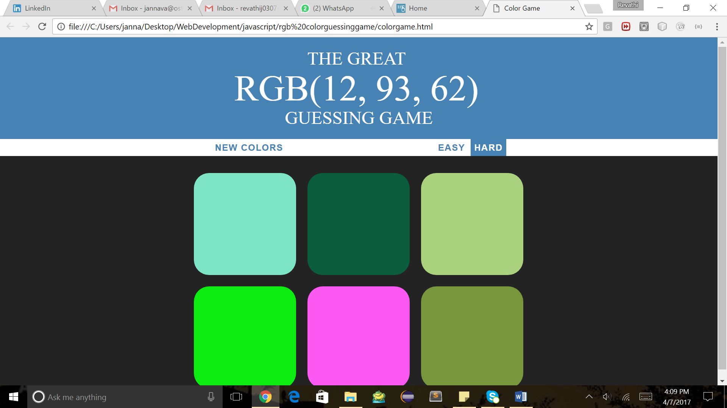

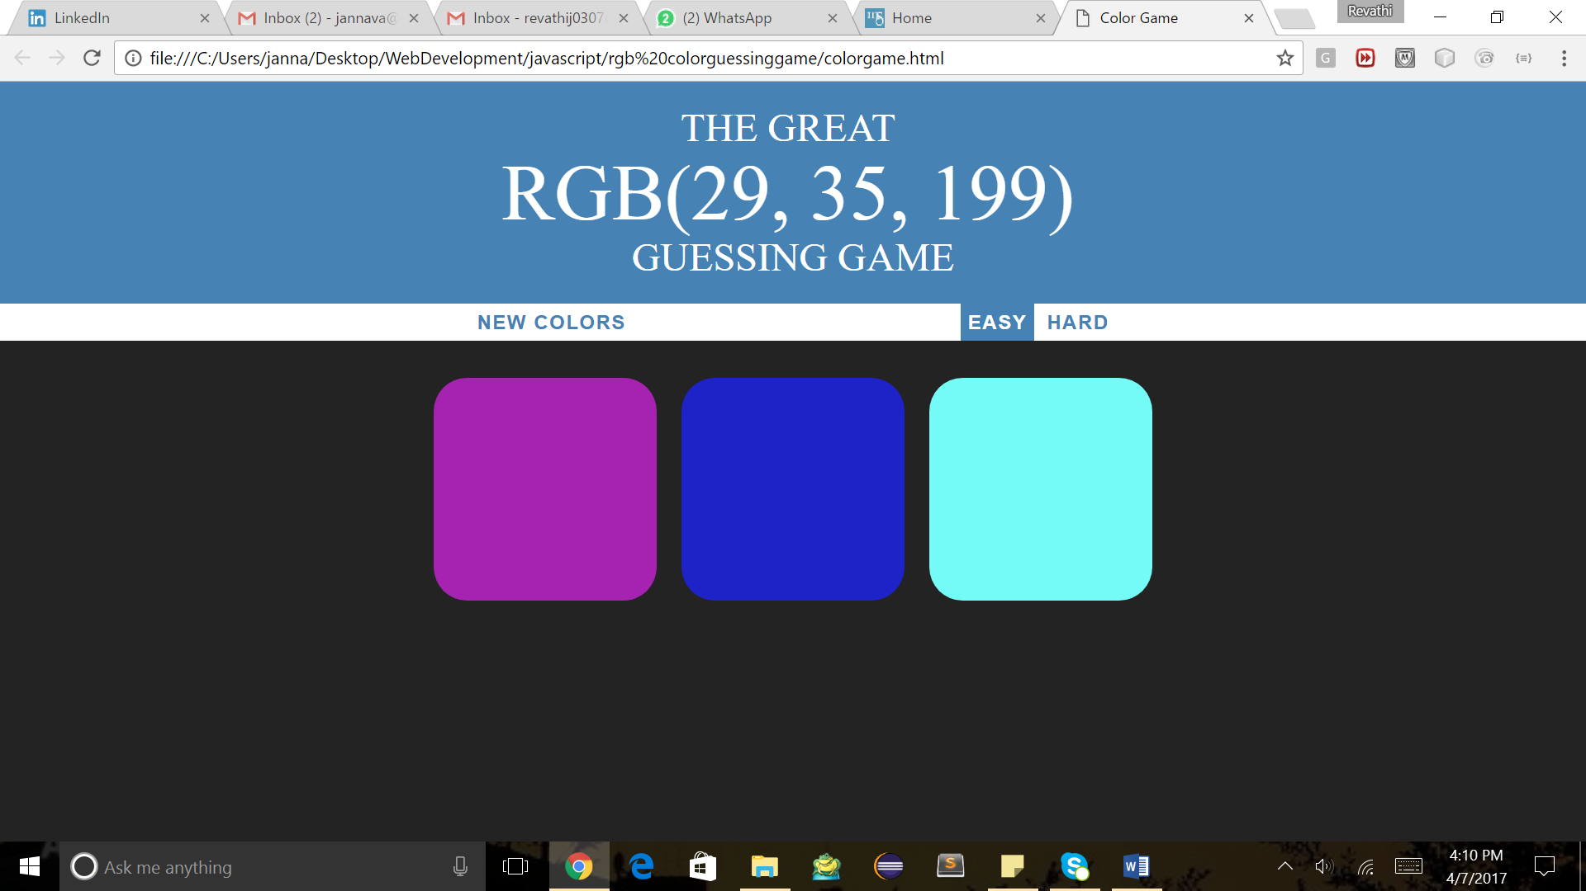

1. We will get the above screen, there are two phases- EASY, HARD

EASY – We will play with 3 color grids

HARD – we will play with 6 color grids

* One RGB format will be displayed on the top, which color will represent that RGB format.

Environment: Sublime Editor, HTML, CSS, Bootstrap, JavaScript, jQuery